Website Discovery Guide
Prepared for KACI Studio · by De Makers Space
Tell us your story. We’ll build the space for it.
Hey KACI team 👋
We’ve been following what you’re doing, and we love it. A Gen Z-run studio in Singapore telling brand stories with soul, structure and a ridiculously good eye — that’s a brief we’re genuinely excited about. Your website needs to do what your content already does on the feed: stop the scroll, hold attention, and make people feel something before they ever hit “Book a call.”
This guide is how we get there. It’s a mix of strategy questions, brand questions, and a few deeper ones about why you started KACI in the first place. Think of it less as a form to fill in, and more as a first conversation on paper.
A few things before you dive in:
• Don’t overthink it. Voice notes transcribed, bullet points, rambling paragraphs — all welcome.
• If a question doesn’t apply, skip it or write “N/A.” We’d rather have honest short answers than forced long ones.
• Feel free to drop links, screenshots, Pinterest boards, TikToks — anything that helps us see what you see.
• Take your time. Send it back whenever you’re ready.
You already tell stories for a living. This is just you telling us yours.
— De Makers Space

01 Your Origin Story
Every studio has a “why we started this” moment. The best websites start there too — so visitors feel the humans behind the brand before they read a single service.
How did KACI Studio actually come to life?
Was it one conversation? A frustration with how brands were showing up online? A shared Notion doc that got out of hand? Walk us through the spark…

KACISTUDIO came about from a shared passion in creating content. We both helped/ experienced / freelanced creating content for brands / clients and ourselves and we really enjoyed what we were doing. Coming together, we also realise that many brands lack content that tells their story and content that are engaging yet intentional at the same time. Many viral content that blew up in sg are mostly funny videos and most of the time they are not the right materials to portray the brand image / voice, and to us its really wasted lol. Hence we want to make kaci a space where contents are curated with intentions that fits their brand and also helps entrepreneurs / founders out there to remove this weight (since many of them don't have the time for social media) off their shoulders.
What does the name “KACI” mean to you — and what do you want it to mean to clients?
If there’s a story behind the name or the .co, we’d love to hear it. If it’s just a vibe, that’s a valid answer too...
KACI was derived from our surnames. Angeline’s surname is Khor and Jovinna’s surname is Chow. After brainstorming and jumbling letters together, we finally settled on KC. We didn't want our brand name to be solely 2 letters hence we added more letters to make KC a name instead. We wanted our brand name to be a little more special and more human (sounding like a name) instead of just KC,, it’s too plain.
What’s the version of the social media industry you’re trying to change?
Cringe corporate content? Agencies that don’t get Gen Z? Brands posting for the algorithm instead of their audience? Be specific — this is where your edge lives…
Like we mentioned above, many brands are just posting for virality, algorithms, what's funny , etc, without caring for their own brand and also what their audience wishes to see. Or on the other hand, the content is just super boring… which no one wants to see. All these contents do not have an intention behind it and it is where KACI wants to come in and help.

02 Your Business, In Your Own Words
Pretend we just met at a cafe in Tiong Bahru and we asked what you do. What would you actually say?
How would you describe KACI Studio to someone you just met?
Not the website copy version — the real, casual, “oh we basically do this” version…
KACI is a Social Media Agency that helps brands show up better online. We help businesses plan what to post, create the content, craft the captions, manage their socials, and make sure their brand looks and sounds consistent. Basically beautifying their social media pages. Instead of just posting for the sake of posting, we help brands figure out what they want to say, how they should say it, and how to turn their products, services, or story into content that people actually want to watch, read, and engage with.
What are the core services clients should leave your site understanding?
e.g. full TikTok & IG management, content shoots, strategy, community growth, caption writing, analytics — but in the order you’d want them to register...
- Social Media Management
  - Planning, content direction, content calendars, captions, posting, scheduling, and community management.
- Content Creation
  - Filming, editing, graphics, reels, carousels, stories, and brand visuals for all social media platform
- Social Media Strategy
  - Helping brands figure out what to post, how to position themselves, what content pillars to use, and how to grow with more intention.
- Events Event Branding & Marketing (THIS IS A NEW SERVICE WE WANT TO LAUNCH TGT W THE WEBSITE)
  - Concept development, creative direction, campaign planning, social media promotion, design of event assets, and onsite styling support for pop-ups, markets, and brand-led events.

Is there a type of project or client you especially want to attract through the new site?
Lifestyle brands? F&B? Beauty? Wellness? Founder-led businesses? Skip if you’re open to everything…
Open to everything.

03 Your Audience
Your website will speak to the people on the other side of the inquiry form. Help us picture them clearly.
Who is the ideal KACI client?
Founder age, type of business, team size, stage they’re at, how much they’ve tried before coming to you. Feel free to describe a real client as a stand-in…
Honestly we don't have any specific type of project or client we want. We’re open to everything but it’s more of the vibe and whether the brand feels aligned with us. With that being said, we are still a boutique and we still have a certain style and direction we lean towards, like what we mentioned above about how we are unlike the mainstream media in sg. For example, we won’t just take in a random chicken rice store as our client.

We want to work with brands that need help with their social media and are willing to take in new ideas from Gen zs.
What are they feeling right before they reach out?
Overwhelmed by posting? Embarrassed by their current feed? Excited to finally get taken seriously? The emotional starting point tells us how the homepage should open...

Overwhelmed by posting, unsure of how to approach their brand’s socials, too busy to manage their social media.

What do they secretly want that they might not say out loud?
A brand they’re proud to share? To stop feeling cringe on camera? To be seen as premium? This is gold for copywriting…

Without a doubt, a brand they’re proud of share but more importantly a brand that tells their story.
Who is NOT your client? (Totally okay to name names or types.)
Knowing who you politely repel is as useful as knowing who you attract...
Like we mentioned…brands like chicken rice stall HAHAHAHAH

Not a client but this is a competitor marketing agency that we feel is totally opposite of what we stand for LOL, Grid marketing.

04 Your Authentic Voice
You run a Gen Z social media studio — voice is half the product. The site needs to sound like the humans behind the DMs, not a polished stranger.
If KACI’s Instagram caption voice and your website voice had to match, what 3–5 words describe that tone?
e.g. warm, editorial, cheeky, honest, soft, confident, a little poetic, not-a-corporate-deck...
Grounded, down-to-earth, elegant, clean, warm
Are there phrases, words or lingos that are very “KACI”?
Signatures you use in captions, sign-offs in emails, how you greet clients, internal team slang that’s made it onto the feed...
“With love,”
Intention
Storytelling
Your story…
Words or phrases you never want on your site?
“Synergy.” “ROI-driven solutions.” “Digital transformation partner.” Tell us what makes you cringe so we can avoid it...
All of the above you just listed.
- CHAOS (like “we help fix your chaos, chaos feed, blah blah anything chaos)
- Raise awareness
- Avoid having “-”
How much personality should come through on the site vs. on your socials?
Same energy? Slightly more polished? More restrained for founders over 40 visiting the site? There’s no wrong answer — we just want to calibrate...
Same energy. We want to be consistent and a brand that feels human.

05 Your Brand’s Personality
If KACI were a person in the room, we want to know exactly who they’d be.
If KACI Studio walked into a brand pitch meeting, how would they carry themselves?
Quietly confident? The friend who finally says the thing nobody else will? The cool-older-sibling energy? Paint us a picture...
Confident, friendly, we won’t let a room go silent for too long. Girl boss energy vibes. Creative.
What’s one thing you’d never want a client to say about working with you?
“They felt like every other agency.” “They were too corporate.” “They didn’t get us.” Tell us the feedback that would genuinely sting...
“TOO YOUNG.”
And the opposite — what’s the dream sentence you’d want a client to leave a review with?
This often becomes the heartbeat of the homepage...
- Love how creative the content is
- Content feels really curated with details

06 The Sensory Experience
Before a visitor reads anything, they’ll feel something. We want to design that feeling on purpose, not by accident.
When someone lands on kacistudio.co, what’s the first feeling you want them to have?
Calm? “Oh, these are my people.” Impressed? Curious? Like they just walked into a quiet, sunlit studio?...
Hopeful, feel like they finally found hope and are able to entrust their socials to us to grow and represent their brand voice online like how they wanted it to be.
What texture or mood is KACI, if it had one?
Warm paper and morning light? Film grain and analog softness? Clean, cool, gallery walls? Be as visual as you like — even metaphors help...
Clean like a pretty boutique store.

If the site were a playlist or a season, what would it be?
Jazz mornings in October? Clairo in a quiet apartment? Late-summer bossa nova? This genuinely informs pacing, type, spacing. Skip if not your thing...
RNB, Peaceful Saturday morning vibes
Is there any motion, scroll behaviour or interaction you love when you see it on other sites?
Subtle image reveals? Scroll-triggered captions? Hover states that feel alive? Drop links if you have them...
Creative but easy to navigate. Eg. Kremi’s website, how more photos reveal upon hovering over one photo.

07 Your Look & Feel
Your Instagram already does a beautiful job of this — sand, espresso, terracotta, that grainy editorial softness. Let’s make sure the site carries it without just copy-pasting the feed.
How closely should the website match your current IG aesthetic?
1:1 extension of the feed? Same palette but more breathing room? A slightly elevated, slower-paced cousin of your socials?...
Same, but can be a little bit more clean.
The vibe should be minimal, intentional, aesthetic, and creative. Warm but professional.
Are there websites (agencies or not) whose design makes you feel something?
Drop links. Even one screenshot with a note saying “this — but warmer” tells us more than a whole brief...

https://www.seventhhousemarketing.com/
- The booking banner at the top
- Use of their brand colours
- “Client Love Letter”

https://www.thelitsocial.com/
- Love their creativity
- Love how the colour matches
- The layout is good as well

https://qoar.id/
- The banner for clients

https://www.studiorh.ca/
- The ‘work with us’
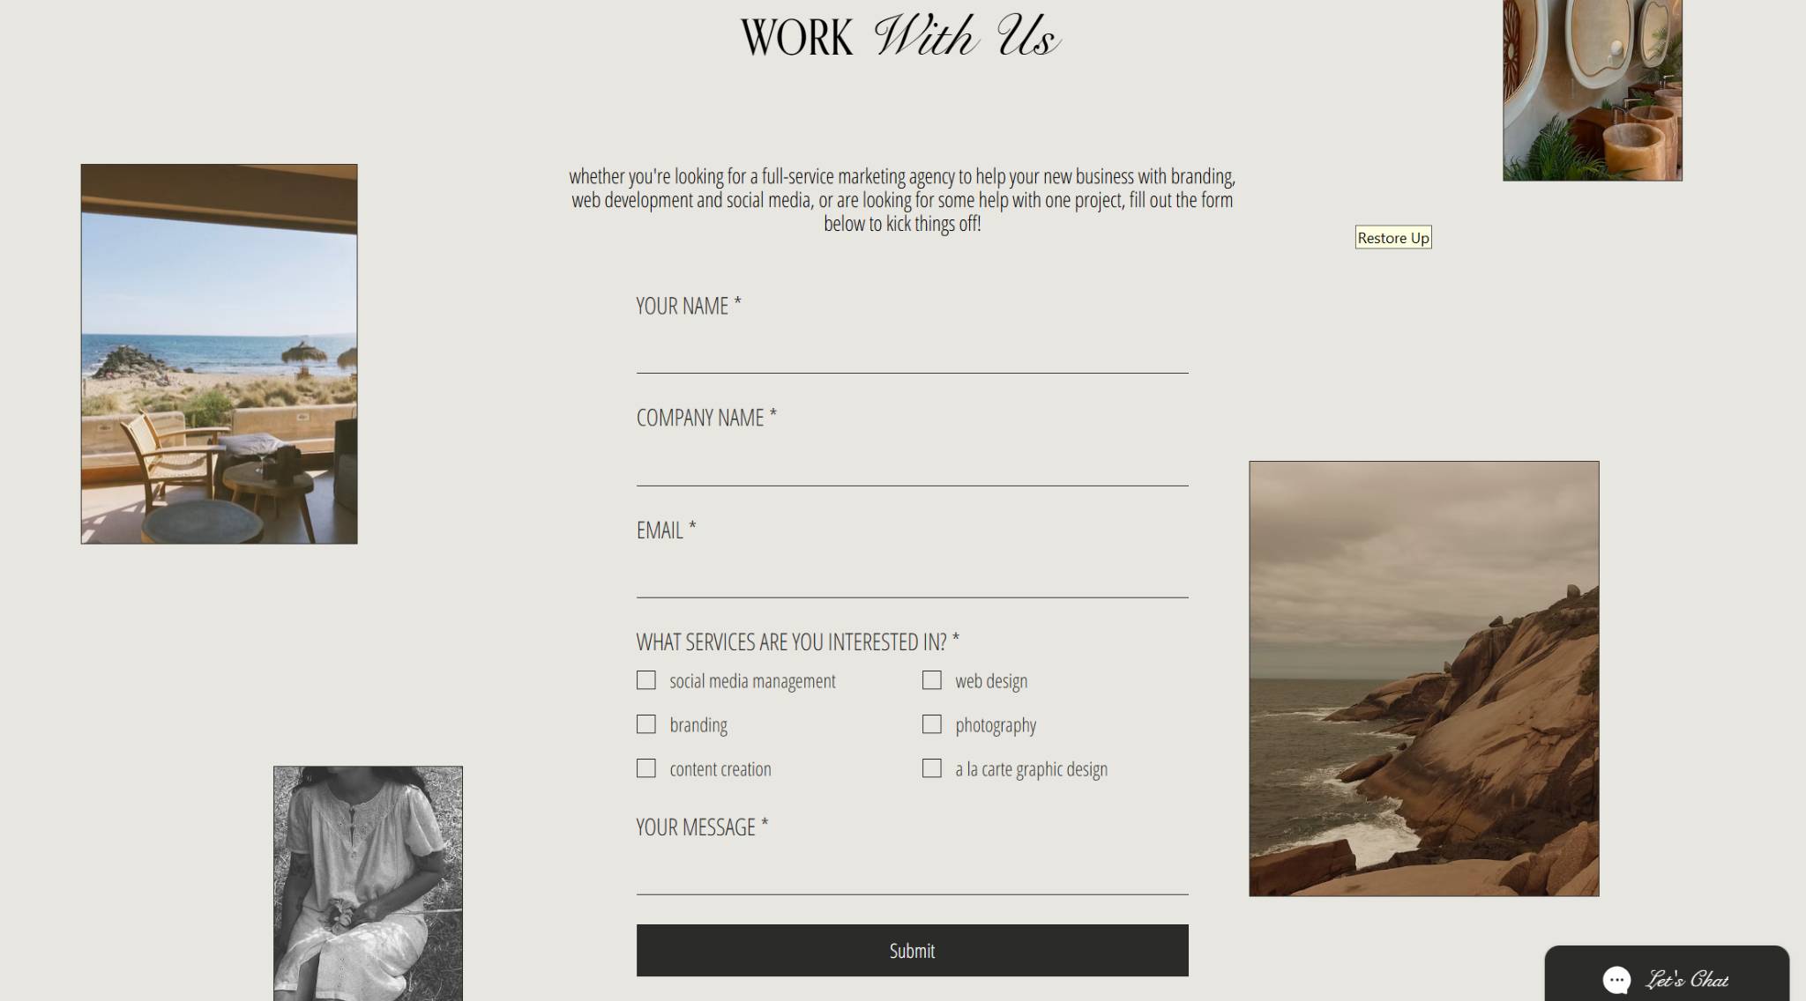

Any looks you absolutely don’t want?
Bro-marketing sales pages, cluttered dashboards, overly corporate blue SaaS sites, neon Gen Z chaos, generic Squarespace templates — name your no-gos...

Dislike overly corporate or cluttered sites. No sales-y vibe.

08 Your Colours
Your palette is already strong. We just want to hear how you talk about it — that shapes how we use it.
Your current palette reads as warm sand, espresso, terracotta, with hints of olive and cream. Does that still feel right, or is it evolving?
Totally fine if you’re reconsidering it — a website rebuild is a great moment to refine...
Here are our official brand colours.

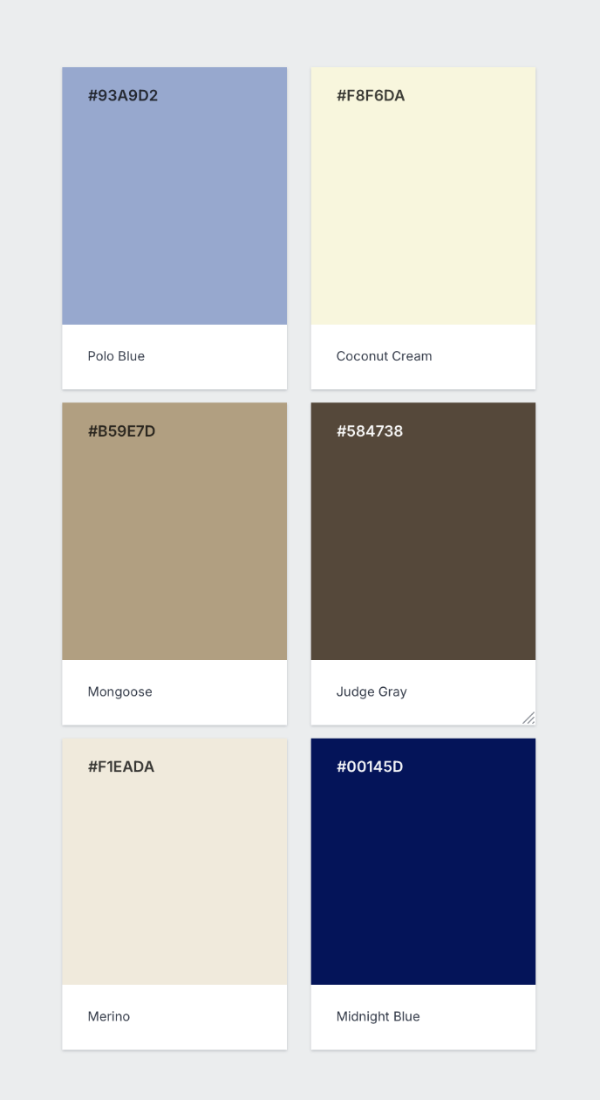

Which colour should do the heavy lifting — and which should be the accent?
e.g. sand as the canvas, espresso for type, terracotta as the “click here” moment...

Honestly, no preference, just play WELL with the pairings. As long as it’s from our brand colour palette.
How do you want visitors to feel the moment the palette hits them?
Grounded? Premium? Like a warm, curated space? Calm before the strategy? Skip if you’d rather we lead on this...
Grounded, warm, elegant, approachable.

09 Tone & Language
Same team that writes your captions will read your homepage in their head. The site has to hold up to that ear.
How do you want the homepage to open — punchy, quiet, poetic, or straight to the point?
A one-liner hero? A short paragraph that feels like a Notes app screenshot? A bold statement? Drop a direction even if it’s rough...
A one-liner hero.
‘Where your story meets socials”
Do you want the site to speak as “we” (the studio), “I” (a founder), or something more brand-like and implicit?
No right answer — just affects everything...
We, the studio. A team not an individual.

Any lines, taglines or phrases you’ve written for KACI that you’re proud of and want us to keep?
“We grow with you, not just for you” already lives beautifully. Anything else in the vault?...
Where your story meets socials.
Crafted with Soul. Created to Connect.

10 Your Current Presence
We want to understand what you already have so the website extends your world, not replaces it.
Outside of Instagram and TikTok, where else does KACI currently show up?
LinkedIn, email, Lemon8, in-person pitches, referrals via existing clients? Any passive channels?...
LinkedIn, email, word of mouth.
What’s working really well in your current presence — that we should protect and amplify?
A specific content pillar? Your carousels? Your DMs experience? The vibe of your highlight covers? Name the wins...
Amplify the uniqueness of our content style and how it’s unlike the mainstream media in Singapore. We take inspiration from many content creators from around the world like Manhattan, New York style.
What’s NOT working, or what feels like a leak?
People reach out but never book? No clear way to see your work? Inquiries come in for the wrong services? This directly shapes the site structure...
Reached out to us but never book.
How are inquiries currently coming in — DMs, email, both?
And do you want the website to change that split, or support it as-is?...
Mostly emails. Email would be good as we check our email more than dms.

11 Competitors & Your Edge
Singapore’s social media agency space is crowded. Knowing who you’re up against — and where you quietly leave them behind — helps us position you right from the first scroll.
Name 2–4 other social media agencies or studios (in SG or anywhere) that you rate.
Links or just names are both fine. Doesn’t mean you want to look like them — just helps us map the landscape...
To be social - https://www.tobesocial.sg/
Get social - https://www.getsocial.sg/
Round 3 - https://www.round3media.com/
What do you respect about their websites or brands?
Be specific — “the way they price transparently” or “the way their case studies are structured” is way more useful than “clean design”...
The best reference is to be social. I love the way they display their work.
What do you think they’re getting wrong — that you’re quietly doing better?
Be honest. No one’s reading this but us...
Round 3 is too childish in our pov…
Your pay-what-feels-right review model is genuinely unusual. How much should we lean into that on the site?
Front and centre as a value prop? Tucked inside the process section? Something you’d rather we mention only when it’s earned further down the page?...

WE TOOK IT OUT HAHAAHAHAH

12 Your Pages & Content
Let’s map out what the site actually needs — no more, no less.
Which pages do you think you need?
Our starting suggestion based on your model: Home, About / The Team, Services & What’s Included, Our Process, Work / Case Studies, Inquire / Contact. Add, remove, or push back…
Home, About, Services/Packages, Case Studies, Contact Details.
Do you want case studies for your current clients (Resurrack x LittleMissMarket, Flyco, Brixx Derma)?
Full write-ups with context, strategy, results? Or more of a visual portfolio grid with Reels embedded? Or both? Skip if you’re not sure yet…
Case studies. Have the results, the end product and a little write up.
How much of your process (the 6 steps) should live on the site?
Full breakdown, condensed version, or something playful and scroll-based?...
Simple breakdown will do, just need to showcase the onboarding process cuz some clients look at turn around time.
Do you already have copy written, or would you like us to help draft it?
No stress either way — we can work from your captions and decks as a voice reference if helpful...
Yes sure

13 Your Images & Media
You’re a content studio — you probably have more assets than most clients. Let’s make sure we use the right ones.
What visual assets do you already have ready to use?
BTS shoot photos, client Reels, carousel mockups, team portraits, studio shots, your logo mark and wordmark...
YEPS will add in google drive. But we are thinking of taking a proper one with the team!

Do you want to feature live Instagram or TikTok embeds on the site?
Embedded posts/Reels can do a lot of heavy lifting for a social media agency — though they come with tradeoffs on loading speed. Happy to advise...
OHHHH YES PLS!

Do you want a short hero video at the top of the homepage?
Could be a 10–15 second cut of your BTS shoot footage. If yes, do you have footage ready, or should we plan a short shoot?...

Ohhh yall even do shootings ah HHAHAHAHAHAH
SURE

Any visual elements we should absolutely include?
Film grain texture, serif + sans pairing, phone mockups showing client feeds, animated scroll numbers — anything you’d feel weird without...
We have our own brand font that we can send u ;)

14 Your Social Proof
Your pay-what-feels-right model is literally built on trust. The site has to reinforce that from the first scroll.
Do you have testimonials or quotes from your current clients?
Resurrack x LittleMissMarket, Flyco, Brixx Derma — even a DM screenshot or a kind voice note transcribed works beautifully...

We don’t have one at the moment but we will think about it later. Maybe write ourselves….
Do you have any before/after results from existing clients?
Engagement lifts, follower growth, a specific Reel that went off, an inquiry spike. Numbers are great but narrative wins work just as well...
Yes we have. Can refer to our brand deck for specific numbers for Flyco, Brixx Derma. For Little Miss Market, let us update u guys on the number again.
Any notable brand partnerships, features, or press we can reference?
Skip if not applicable — we can build trust other ways...
NIL

15 Your Goals
Every page should be working toward something. Let’s get clear on what the site actually needs to do for the business.
What’s the ONE action you want a visitor to take?
Send an inquiry via form? DM you on Instagram? Book a discovery call directly? Download a services deck? Pick the primary...
Gather their contact details, budget (basically everything we have in our google form) then we contact them from there.
What’s the secondary action for visitors who aren’t ready to reach out yet?
Follow you on IG/TikTok? Read a case study? Save the site for later? Join an email list?...
Check out our social media account and follow us there.
How should the $500 deposit be introduced on the site — if at all before the inquiry?
Some agencies hide pricing entirely; others lean into it as a filter. Given your model, we suspect leaning in works — but you know your audience best…
Removed this option can skip.
How many inquiries per month would make this site feel like a success, 3 months post-launch?
Realistic, not aspirational. Helps us measure post-launch...
About 50-80 inquiries would be good to hear..

16 Features & Integrations
Let’s make sure the site actually does everything you need it to — without bloat.
Which of these do you think you’ll need?
Inquiry form, Calendly/booking integration, Instagram feed embed, TikTok feed embed, deposit payment link (Stripe/PayNow), email list signup, case study CMS, blog/Journal section, WhatsApp quick-contact button...
Inquiry page, Instagram feed embed, Tiktok feed embed, contact details, case study.
Do you want a password-protected page for prospective client proposals?
Some studios use a custom link per prospect — super premium, totally optional. Skip if not for you...
Nope. Proposals will be sent personally after the discovery call.
Any specific integrations with tools you already use?
Notion, Google Workspace, ConvertKit/Mailchimp, Later, Airtable, a CRM? Skip if none...
None of the mentioned. We use Milanote

17 Logistics, Timeline & Budget
The boring-but-important stuff. Be as honest as you can — it genuinely helps us scope well.
Do you already own kacistudio.co — and the hosting, if any?
If yes, we’ll chat login details separately. If not, we can sort it together...
Yes.
Do you have any legal pages already, or do we need to include them?
Privacy policy, cookie notice, terms of service. For an SG agency handling client brand assets, we’d recommend at least a privacy policy...
Whatever you recommend. Thanks!

Is there a launch date you’re working toward?
A client campaign? A content drop? A quiet soft-launch window? Even “no hard deadline” is useful...
Not really but preferably before the second half of the year.
What’s your budget range for the build?
No judgement here — it just helps us recommend the right scope. If you’d rather we quote based on scope first, that’s also totally fine…
As per discussion, let’s go ahead with $650/month

18 Looking Ahead
The site should grow with KACI, not hold it back a year from now.
Where do you see KACI in 12–18 months — and how should the site be built to support that?
New service tiers? A UGC creator network? Expansion beyond SG? A digital product or mini-course? A physical studio space?...

Our goal is to make KACISTUDIO a creative space and not just a social media agency alone. We are aiming to add in new services as we grow, such as branding etc.
Would you like to manage site updates yourself, or have us handle ongoing support?
We offer The Ally Add-on for post-launch maintenance — technical updates, content refreshes, new case studies added. Totally optional. If you’d rather manage in-house (very Gen Z studio energy), we’ll build it so you can...
It would be great if you guys can handle ongoing support ;)

Is there anything we haven’t asked that you really want us to know?
A fear, a hope, a pet peeve, an inside joke that should make it onto the 404 page — open floor...
name KACISTUDIO ( in full caps and no spacing ) and not Kaci Studio HAHAHAHAH
That’s a wrap 🎉
Seriously — thank you for giving this the time. The depth you bring to this guide becomes the depth we can bring to the site. Every detail you share, even the ones that feel small or unfinished, becomes material we can shape into something that feels completely, unmistakably KACI.
Send it back whenever you’re ready. We’ll read it properly, not skim it, and come back to you with first thoughts, questions we’re sitting with, and a proposed direction for the build.
You tell brand stories for a living. We can’t wait to help tell yours.
— De Makers Space
De Makers Space · demakersspace@gmail.com · @de.make

